Commission is defined as a percentage of the hourly rate. But that is equivalent to saying a percentage of the total chargeable amount. So you don’t need to know the number of hours so far charged to work out the commission, you just need the total chargeable amount. As far as working out commission, and how much the client owes, it makes no difference if you itemise the sessions or not. So this (where the sessions are itemised)...

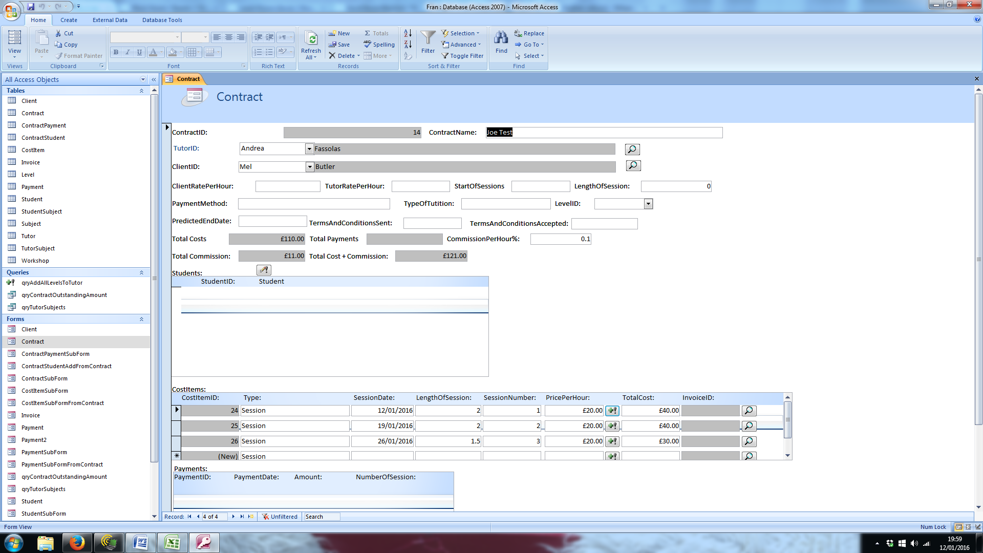

Is the same as this, where they are not.

